**ID: 553-24 H**

**Electrical Systems for Transportation**

**PSCADA in Red-line TLV**

**מערכת הסקדה בקו האדום בתל-אביב**

**Keren Cohen**

CRTG-EEB, Israel

[keren4co@gmail.com](mailto:keren4co@gmail.com) 052-5219218

PSCADA system on the Red Line in Tel Aviv.

Introducing the AC system, DC system, and automatic scenarios for operating the generation system for the underground stations.

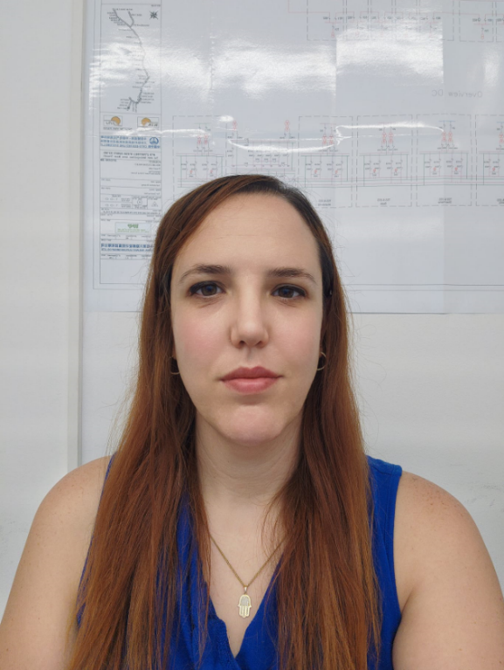

2023 -Present: Maintenance Electrical department manager, CRTG-EEB, Red Line Systems

2021-2023 : T&C Electrical department manager, CRTG-EEB, Red Line Systems.

2019 - 2021: LV & MV Product Manager, ABB Technologies Ltd.

2015 - 2019: Service Engineer, TC Electrical Systems.