**ID: 457-24 E**

**Green Construction & Zero Energy Construction**

**CFD for Enhancing Data Center & Infrastructure Airflow and Temp**

**סימולציותCFD לשיפור של זרימת האוויר והטמפרטורות ב DC**

**Dr. Eldad Levy**

CAS, Israel

[Eldad@cas.co.il](mailto:Eldad@cas.co.il) 054-4663344

CFD Simulation for Enhancing Data Center and Infrastructure Airflow and Temperature Management

Data centres, as the backbone of modern digital infrastructure, face increasing challenges in maintaining optimal operating conditions due to escalating computational power and energy consumption. This study explores the using of Computational Fluid Dynamics (CFD) simulation as a robust tool for improving airflow and temperature management in Data Centre as well as the supporting infrastructure such as generators, chiller and cooling towers rooms and roofs. By meticulously modelling the complex interplay between heat generation, air distribution, and equipment arrangement, CFD enables a comprehensive understanding of thermal behaviour within data centre and the supporting infrastructure environments. It enable to check “what if cases” through virtual experimentation, various design configurations, failure cases, cooling strategies, and operational parameters can be evaluated to identify and mitigate hotspots, optimize air flow patterns, and minimize energy consumption. The findings of this study demonstrate the potential of CFD to significantly enhance data centre efficiency, PUE, reliability, and sustainability by providing data-driven insights for informed decision-making and predictive maintenance. Some different cases of Data Centre in different sizes and structure will be shown. Supporting infrastructure such Generators Chillers and Cooling Tower at the underground and roof location will be shown as well

.

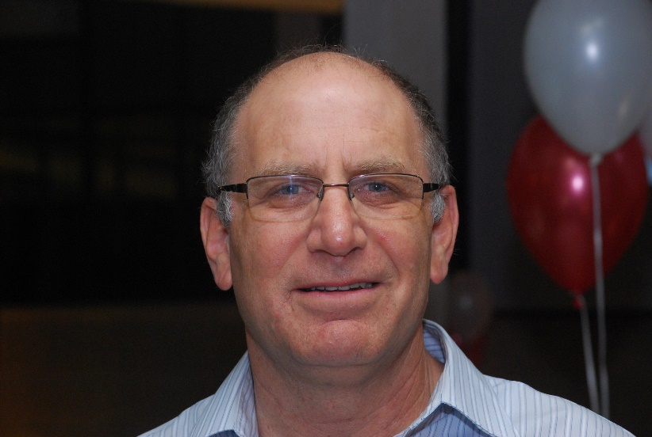

Eldad Levy - PhD on” Exact Calculation for Dynamic and Buckling Loads of a Space Truss with a Large Number of Degrees of Freedom” (Technion institute of technology, Haifa, Israel). Ms.c. “Solar Air Heater with Semi-fluidized Bed “ from the Technion as well.

During these years, Mr. Levy specialized in numerical simulation, and now he mostly specialized in electronic cooling from all sizes and all fields.

Since 1995, Mr. Levy is CAS Ltd. CEO. CAS Ltd. has a staff of about 12 engineers that specialized in the field of thermal, dynamic, mechanical, CFD and optimization conceptual design and simulations consulting.

During the years CAS Ltd. was involves in the design of hundreds of products at the Military, Medical, Telecom, Datacom and lot more markets