**ID: 480-24 H**

**R&D in Energy Engineering**

**The Mediterranean Dead Sea Channel Solution**

**תעלת ים התיכון ים המלח**

**Prof. Moshe Averbukh**

Ariel University, Israel

[mosheav@ariel.ac.il](mailto:mosheav@ariel.ac.il) 052-881420

The sustained growth in electricity demand in Israel necessitates the expansion of electrical infrastructure to accommodate increased requirements for electrical transportation and domestic consumption. It is anticipated that future increases in electricity demands will primarily be met through renewable energy sources, particularly photovoltaic (PV) power stations. However, the widespread adoption of solar electricity poses a potential challenge to the stability of Israel's isolated energy grid, particularly in terms of frequency stability and voltage control within distribution lines. Mitigating this challenge requires the integration of electrical storage solutions.

An optimal solution, consistent with Israel's geographical characteristics, entails the construction of a channel linking the Mediterranean and the Dead Sea. This proposal involves the establishment of reservoirs for energy storage and hydroelectric power stations along the descent to the Dead Sea. The deployment of such hydro stations has the potential to ameliorate the disruptions to frequency and voltage stability stemming from the increasing output of solar electricity, which is inherently subject to significant stochastic variations. Additionally, this project offers supplementary benefits, including the production of desalinated water, mitigation of the impending decline of the Dead Sea, and promotion of landscaping initiatives such as the development of recreational health centres and resorts in desert areas.

. 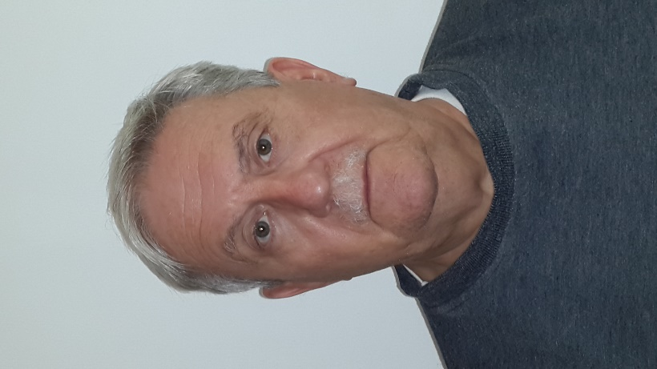

Professor Moshe Averbukh obtained his Ph.D. in Applied Science in 1984 from the Skochinsky Institute of Mines in the former USSR. From 1984 to 1991, he conducted research at the institute before relocating to Israel in 1991. In Israel, he worked at IMI and subsequently at various Academic Colleges and Ben-Gurion University as a researcher. Since 2013, Professor Averbukh has been a faculty member at Ariel University, where he was appointed Associate Professor in 2022.

Throughout his career, Professor Averbukh has taught over eight undergraduate and six graduate courses, fostering the academic development of numerous students. Under his guidance, 43 students earned B.Sc. degrees, 11 obtained M.Sc. degrees, and 2 achieved Ph.D. degrees.

Professor Averbukh's research contributions are extensive, with more than 46 articles published in top-tier scientific journals. Additionally, his work has led to the acquisition of 6 patents in the USA and 14 in the former USSR, showcasing his innovative prowess in the field.